The History of the RWCCO

In 1986, several dedicated individuals from Roberts Wesleyan College and the community put together their vision for developing a joint college and community orchestra that would not only provide an ensemble experience for music students, but would also become a significant part of the area’s cultural enrichment. Under the musical direction of Nyela Basney, that vision soon became a reality. As the orchestra blossomed and strengthened its musical muscles, its visibility and appreciation in the western part of Monroe County grew.

Growing steadily in musical excellence and programming since its beginning in 1986, the orchestra now boasts highly skilled regional and college musicians who perform the highest quality orchestral repertoire. In addition to a classical concert series, the orchestra performs an annual educational concert for 3rd graders, providing the opportunity for nearly 1000 children each year to experience a live orchestra and learn about instruments at no cost to the schools. The orchestra is committed to providing these live orchestral experiences to those living in western Monroe County and surrounding areas.

Coming Events

Saturday Wind Ensemble Homecoming Hale Auditorium
September 29 4:15 pm

Tuesday Jeffery McGhee, Joshua Bouillon, Michael Landrum Shewan Recital Hall
An Evening of Art Song, Opera & Sacred Song 7:30 pm

Sunday Honors Band Festival Concert Hale Auditorium
October 21 2:30 pm

Thursday Junior Recital: Sarah Thomson Shewan Recital Hall
October 25 7:30 pm

Saturday Chorale: Rutter’s Gloria Union University Church (Alfred, NY)
October 27 With the Alfred University choirs 7:30 pm

Sunday Men’s Chorus & Women’s Choir Hale Auditorium
October 28 3:00 pm

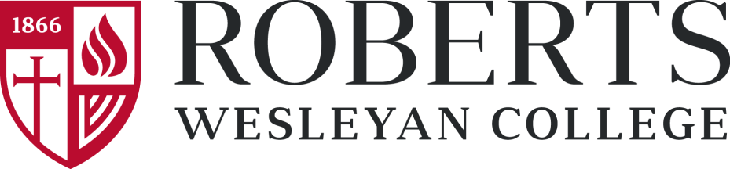

presents

A Night at the Movies
Music from the Silver Screen

RWCCO
Paul Shewan, director

With the RWC Chorale
Adam Potter, director

Friday, September 28, 2018 at 7:30 p.m.
Andrews B. Hale Auditorium
Howard Stowe Roberts Cultural Life Center
Program

The Pink Panther Henry Mancini

Die Walkure: Ride of the Valkyries Richard Wagner
(from Apocalypse Now)

Adagio for Strings Samuel Barber
(from Platoon)

Carmen: Habanera Georges Bizet
(from Up: “Wake up Carl”)

Parade of the Charioteers Miklos Rozsa
(from Ben-Hur)

Movie Medley
Chelse Chambers, Joshua Bouillon,
Léa Hossack Bouillon,
soloists
Michael Van Allen and Daniel Barta,
pianists

Intermission

Batman Theme Danny Elfman
The Cowboys John Williams

Requiem: Dies Irae and Confutatis* W. A. Mozart
(from Amedeus)

Hymn to the Fallen* John Williams
(from Saving Private Ryan)

Star Wars: The Phantom Menace Suite John Williams
Flag Parade
Anakin’s Theme
Adventures of Jar Jar
Duel of the Fates*

*With the RWC Chorale

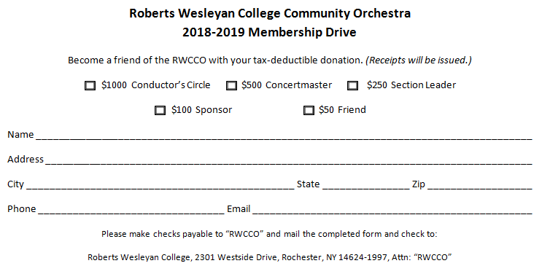

RWCCO FRIENDS 2018-2019
Conductor’s Circle ($1000+)
Robert Shewan
In memory of Nancy Shewan

Concertmaster ($500+)

Section Leader ($250+)

Sponsor ($100+)
Lloyd & Neva Donnell
Lesley D. Eich
Marilynn C. Tullar

Friend ($50+)
Bill & Kay Blake Hunt
Paul & Sally Renter
Ann E. Rogger
Michael & Gretchen Santangelo
Judith Schimp

Paul Shewan

Paul Shewan is Professor of Music at Roberts Wesleyan College where he conducts the Wind Ensemble and the Orchestra, and teaches trumpet, brass methods, and instrumental conducting. He earned his undergraduate degree in Music Education from Roberts Wesleyan and a master’s degree in Trumpet Performance and Literature from the Eastman School of Music. He completed the doctoral degree in Conducting from the Eastman School of Music in 2004. At the Eastman School, Dr. Shewan studied conducting with Mendi Rodan, Neil Varon, Donald Hunsberger, and Mark Scatterday. He appeared in several concerts conducting the Eastman Wind Orchestra, the Eastman Conducting Orchestra, and the Eastman Wind Ensemble. In the summer of 2004, he conducted the Eastman Wind Ensemble on its four-week tour of Japan, Taiwan and Macau. He has returned to Eastman as a visiting professor of conducting.

Paul has conducted the Rochester Philharmonic Orchestra on numerous occasions and is a member of the RPO trumpet section. He has also performed several times with the Buffalo Philharmonic Orchestra. Dr. Shewan has conducted and performed as trumpet soloist for live public radio broadcasts. He has recorded as trumpet soloist and conductor for the Albany, Bay Cities and Mode recording labels. His most recent recording as conductor includes Randall Thomson’s Frostiana for chorus and orchestra, and Ron Nelson’s Te Deum for chorus and band. As an active guest conductor, Dr. Shewan conducted Concordia Santa Fe (New Mexico) in 2012. He has been a guest conductor of the Syracuse Youth Orchestra and the Rochester Philharmonic Youth Orchestra. Each summer he conducts the orchestra at the Csehy Summer School of Music.

Violin I
Grace Flier
Concertmaster
Karen Marsh
Lydia Holdridge
Iuliia Trishchuk
Mingjie Gao
Kristin Kant-Byers
Kelly Laraby
Kate Wagner
Lori Hyde
Marleese Patterson

Violin II
Sharon Snell
Principal
Nathan Sawyer
Xiaowei Jia
Lingling Wei
Jenny Honan
Millicent Lake
Amy Mitchell
Gabrielle Antonio
Kelly McNamara
Hayley Jensen

Viola
Jessica Brabant
Principal
Julia Thayer
Kristen Swift
Mona Seghatoleslami
Patricia Goole
Amy Scobey
Marirose Dempsey
Victoria Urbanczyk
Natasha Moshkovskiy
Ethan Snell

Cello
Victoria Yu
Principal
Ruth C. Perea
Aaron Liu
Luke May
Eric M. Gambino
Blanche Wen
Ruth S. Stork
Vivian Dai
Rachel Fan

Bass
Cheryl Guth
Co-Principal
Nick Parker
Co-Principal
Wally Comfort
Steve Keenan

Flute
Cassandra Dries*
Emily Hutchinson*
Ashley G. Moss

Piccolo
Emily Hutchinson

Oboe
Kathleen Holt*
Laurie Luce*
Katie Southard*

Clarinet
Scott Horsington*
Lysa Kindred*
Yelin Wang*
Russ Conjerti

E-flat Clarinet
Lysa Kindred

Bass Clarinet
Russ Conjerti

Bassoon
Jillian Beaman*
Jeanne Coonan*

Contra-Bassoon
David Keller

Soprano Saxophone
Collin Murtaugh

Alto Saxophone
Collin Murtaugh
Weichen Zhang

Tenor Saxophone
Charlyne Olick
Myles Boothroyd

Baritone Saxophone
Tom Zhang

Horn
Natalie Jackson*
Mark Reynolds*
David Shewan*
Nicole Sturdivant

Trumpet
Tierney McLean*
Joshua Meyer*
Paul Shewan*
Steven States*
Janette LaBarre
Will Musengo

Trombone
Joseph Condoluci*
Vincent Huang*
Jeffrey Cai

Bass Trombone
Bob Wilkins

Tuba
Owen Davis

Timpani
David R. Ciarvella
Principal
The John McNeill
Principal Chair
Jonathan Pereira

Percussion
David R. Ciarvella
Heather M. Hubbell
Theresa Lippa
Cheryl Parnell
Jonathan Pereira
Jared Steinmiller

Harp
Elizabeth Honan

Piano
Siu Yan Luk

Orchestra Manager
David R. Ciarvella

Orchestra Librarian
Charlyne Olick

Orchestra Stage Managers
Evan Dick
Rebecca Mugnolo
Tyler Rifenburg
Julia Steidle

*Indicates Rotating Principal

ORCHESTRA PERSONNEL

Alma Mater

Verse:
For over a full century all glorious and grand,
Our Alma Mater now has stood an honor to the land;
Amidst her fields of waving grain, her fruit trees loaded down,
She stands a noble monument of glory and renown.

Refrain:
Then to Roberts Wesleyan College,
We render our best praise,
To our fair school of learning
Our glad voices we now raise;
In this land of light and knowledge
With which we all are blest,
‘Midst so many Alma Maters
Our dear Roberts is the best.

Verse:
And so for Roberts firm and strong with loyalty we stand,
A host of zealous students from all parts of our fair land;
With energy and deeds of might and every skill we know,
We’ll work for her, we’ll pray for her that she may always grow.

(Repeat Refrain)

Violin I
Karen Marsh
Concertmaster
Lydia Holdridge
Grace Flier
Lily Wei
Nathan Sawyer
Joshua Fugate
Mark Scheda
Kristin Kant-Byers
Kelly Laraby
Rebekah Spicer
Lori Hyde

Violin II
Sharon Snell
Principal
Mingjie Gao
Xiaowei Jia
Kate Wagner
Naomi P. Torsleff
Marleese Patterson
Millicent Lake
Jenny Honan
Jonathan Holland
Amy Mitchell
Gabrielle Antonio
Kelly McNamara
Emily Luna
Stephanie Poris
Hayley Jensen

Viola
Jessica Brabant
Principal
Julia Smith
Kristen Gregory
Mona Seghatoleslami
Patricia Goole
Amy Scobey
Natasha Moshkovskiy
Victoria Urbanczyk
Andrew Rudolf

Cello
Victoria Yu
Principal
Ruth C. Perea
Zikang Liu
Luke May
Eric M. Gambino
Xin Yu Wen
Vivian Dai
Qimin Fan
Luke LaBoy

Bass
Nick Parker
Principal
Cheryl Guth
Meagan Bruso
Steve Keenan

Flute
Gillian Buettner*
Emily Hutchinson*
Ashley G. Moss*

Piccolo
Emily Hutchinson
Ashley G. Moss

Oboe
Kathleen Holt*
Qiming Sheng*
Katie Southard*
Laurie Luce

English Horn
Kathleen Holt

Clarinet
Scott Horsington*
Lysa Kindred*
R.J. Miller*
Yelin Wang*

E-flat Clarinet
Scott Horsington
Lysa Kindred

Bass Clarinet
Scott Horsington

Bassoon
Jillian Beaman*
Jeanne Coonan*
David Keller*

Contra Bassoon
David Keller

Tenor Saxophone
Collin Murtaugh

Horn
Katherine Christner*
Mark Reynolds*
David Shewan*
Karen Reynard

Trumpet
Dina Alexander*
Joshua Meyer*
Janette LaBarre
Brandon Luce

Trombone
Joseph Condoluci*
Vincent Huang*
Jeff Dick

Bass Trombone
Bob Wilkins

Tuba
Owen Davis

Timpani
David R. Ciarvella
Principal
The John McNeill
Principal Chair

Percussion
Heather M. Hubbell
Theresa Lippa
R.J. Miller
Cheryl Parnell
Jonathan Pereira
Jared Steinmiller

Harp
Elizabeth Honan

Keyboards
Parker Story

Orchestra Manager
David R. Ciarvella

Orchestra Librarian
Luke May

Orchestra Stage Managers
Ryan Case
Rebecca Mugnolo
Tyler Rifenburg

Concert Manager
Lillia Woodbury

Concert Stage Managers
T.J. Cappiello
Sam Coatsworth
Michelle Garrett
Marissa Shaver
Brad Ward
Alex Zydel

*Indicates Rotating Principal

ORCHESTRA PERSONNEL

